PHOENIX FAMILY REUNION 2017

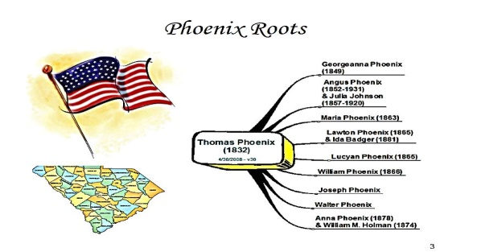

As far as we can trace by oral history, stories and clues left by the prior generations the “PHOENIX” has been one of the strongest families and clans. Thanks to Thomas Phoenix born in 1832 we can trace our roots back to South Carolina, Barnwell to be exact. (Albert Perry The Oldest DNA was found in South Carolina)

This is to shed a little light on our journey before the year of 1832. Let’s take a minute to think back to the year 1832 and what our people were experiencing.

March 3 - In Worcester v. Georgia, the United States Supreme Court holds that Cherokee Indians are entitled to federal protection from the actions of state governments.

March 24 - In Hiram, Ohio a group of men beat, tar and feather Latter Day Saint movement founder Joseph Smith.

April 6 - The Black Hawk War begins.

May 9, 1832 - Lafayette College classes begin.

May 21–23 - 1832 Democratic National Convention held in Baltimore.

July 10 - President Andrew Jackson vetoes a bill that would re-charter the Second Bank of the United States.

July 24 - Benjamin Bonneville leads the first wagon train across the Rocky Mountains using the South Pass (Wyoming).

July–August - The 1829–51 cholera pandemic reaches the Northeastern seaboard, beginning with New York City. [1]

August 27 - Black Hawk (Sauk leader) surrenders to the authorities, ending the Black Hawk War. October 8 - Washington Irving and Henry Leavitt Ellsworth arrive at Fort Gibson, Indian Territory (later Fort Gibson, Oklahoma) in the late morning hours. They leave the fort on October 10, with a small company of Rangers who escort them to the camp of Captain Jesse Bean who is waiting for them near the Arkansas River. Thus begins one of the first steps in the United States effort to remove the indigenous peoples of the Americas from their homes on the east coast in what would become known as the "Trail of Tears" some six years later.

Which brings us to our current History of knowing that the Cherokee Estate 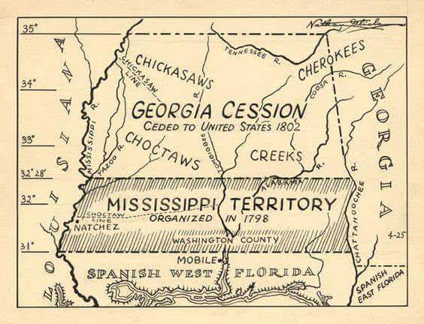

Extends from North Carolina, South Carolina, Georgia (Echota Nation), Tennessee (Tanasi), 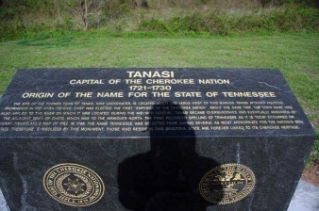 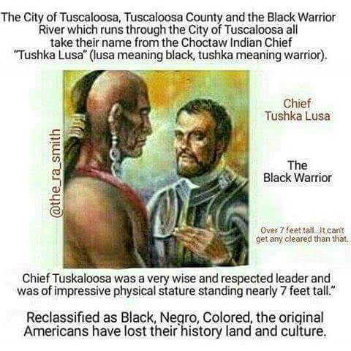

Alabama (Ali-Bama) and Northern Florida.

South Carolina was always important to me because it was my first book report I had to do a presentation on in 2nd grade in Ms. Johnson’s class. I remembered that it was a Cherokee settlement early as 1000 B.C.

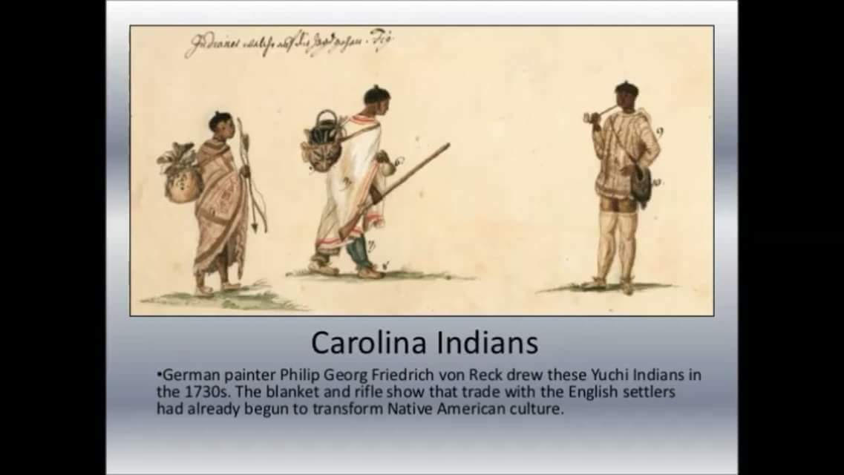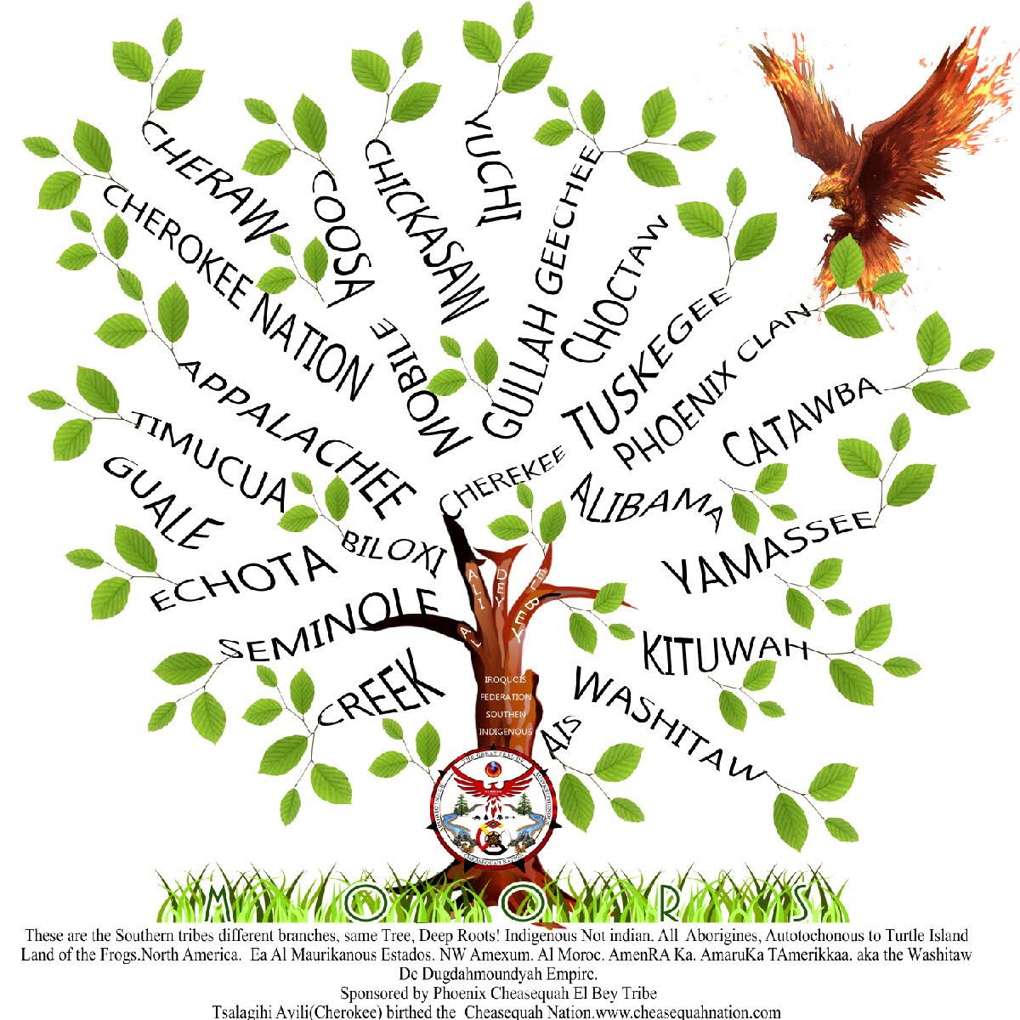

At least 30 distinct groups of Native Americans lived there prior to European Colonizers arrived. Catawba, Chicora, Santee, Cheraw, Wacoamaw, Pedee, Congaree, Yuchi(Euchee) Westoe, Kusso- Natchez, Coosa, Kiawah, Ashepoo, Combahee, Eimbee, Yemassee, Stono, Etiwan, Cofiitachiqui, Escamacu, Wimbee, Wando, Winyah, Wataree, Eno Shakori, Edisto, Saluda, Waxhaw, Sugeree, Sampit, Muskogean, Cuasbo, Bohicket, Siouan, Iriquoian.

Doing a basic Google search you will find found out about the Cherokee Phoenix

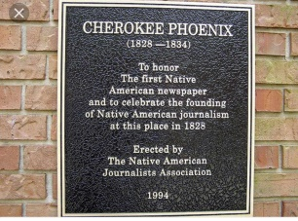 (Cherokee: ᏣᎳᎩ ᏧᎴᎯᏌᏅᎯ, translit. Tsalagi Tsulehisanəhi) was the first newspaper published by Native Americans in the United States and the first published in a Native American language. (Cherokee Phoenix – Wikipedia https://en.wikipedia.org/wiki/Cherokee_Phoenix) So this was Great news to actually see his family name in the actual language of the Original Copper colored Tsalagihi Ayili (Cherokee) that means our clan was a very strong and Prideful clan.

We are the Ani Gatogewi, the wild Potato Clan, known for our agriculture, also known as the Raccoon Clan.

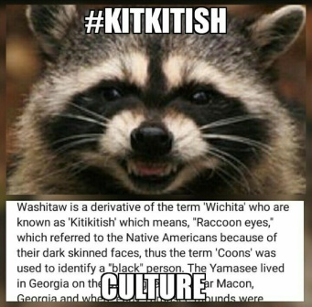 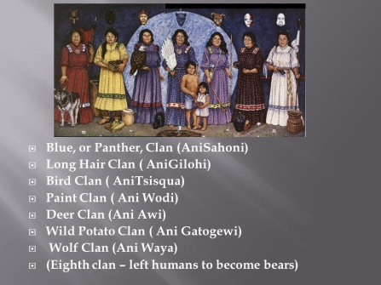 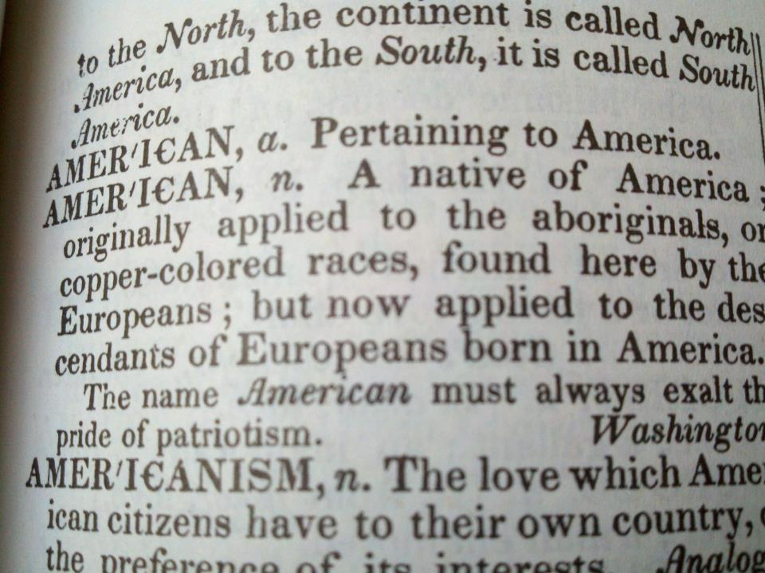

I learned in his Moorish/Muurish studies that the raccoon or Coon was a label of the Kitkitish, (Kituwah), Washitaw or Yamasee that lived in Georgia. They were called coons not because they were sell outs, as the term is known for today but had dark circles around their eyes and fought fiercely like raccoons do.

The Phoenix was such a Strong clan that is was the Cherokee Logo, 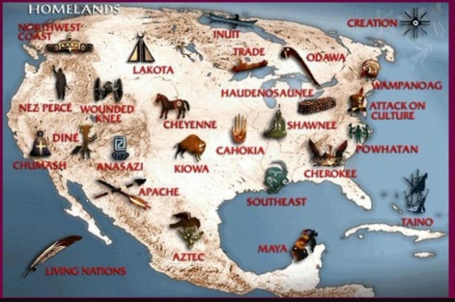

As well as the symbol of the city of Atlanta, 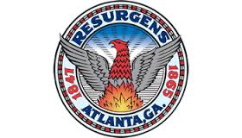

Where I mostly reside.

Realizing my family clan name is sacred I founded the family’s Phoenix Cheasequah El Bey Tribe and became the Principal Chief of the Cheasequah Nation.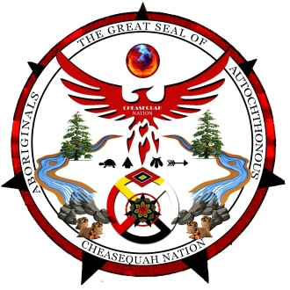www.cheasequahnation.com

Phoenix being our family’s Clan name and Foundation. Cheasequah meaning “Red Bird” in Cherokee, and a Phoenix is a Red Fire Bird

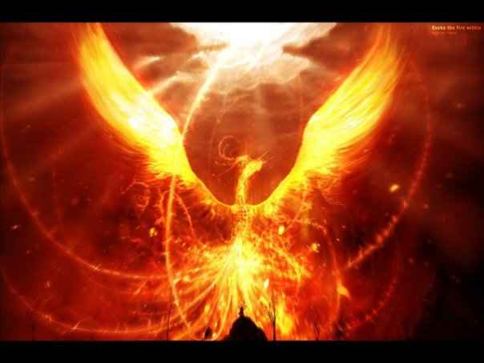  

Also Falcons and Hawks can be RED.

EL is the (Cherokee) title of who were recognized as the “Iroquois Federation” by the House of Representatives Philadelphia Resolution 75 April 17, 1933. And Bey being his New Indigenous Appellation.

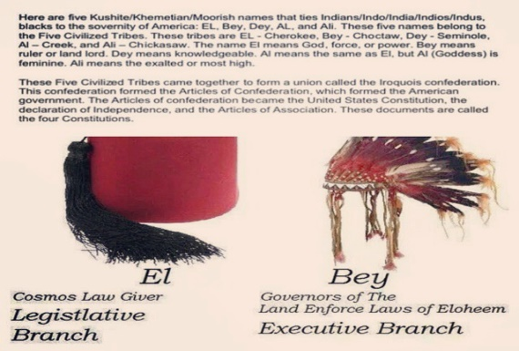

Having the family records of names and birthdates of Ancestors in the family up until 1832 thanks to Thomas Phoenix born in Barnwell, South Carolina. All of the Phoenix Family spoke in a Geechee or Guale, dialect and all had “Redskin” and were known as Redbones that’s where Red came from in his name, he was called “Red” all while growing up: 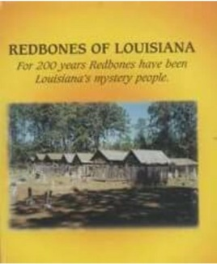

“There are a singular race of people in South Carolina called the Redbones. Their origin is unknown. They resemble in appearance the gypsies, but in complexion they are red. They have accumulated considerable property and are industrious and peaceable. They live in small settlements at the foot of the mountains and associated with none but their own race. They are a proud and high spirited people. Caste is very strong among them. They enjoy life, visit the watering places and mountain resorts, but eat by themselves and keep by themselves.”- Interview with Senator Hampton (Book of Redbones)

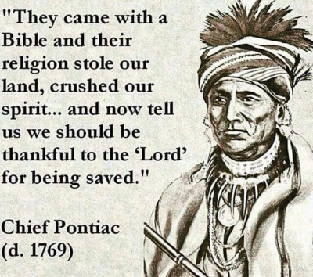 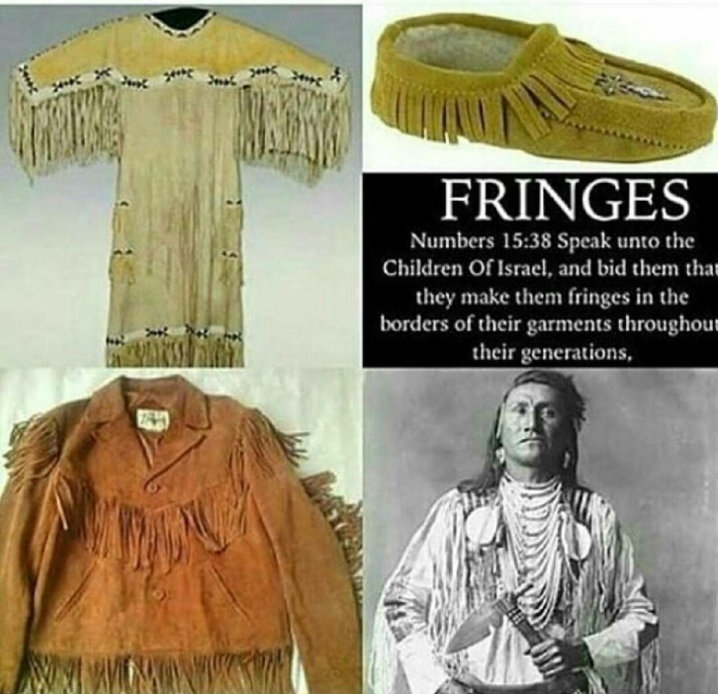

Chief Red wolf has been mentored by Queen Chief Flying Mink of the Deep South Cherokee Keetoowah Foundation. She has been given authority to reclaim her land in South Georgia. Red Wolf has been made deputy chief liaison to be a Chief in training under the Kituwah Band.

“The Cherokee Keetoowah (Kituwah) AniKeetoowahGee Tribes were the Spiritual Sects of the Indigenous people. They were left alone, and granted the “Freedmen Status “, from the inception; for they were with many skills and talents that were used by the Colonizers, until they gained controlled over Georgia in 1776. 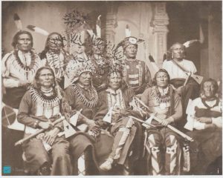

In 1783, Georgia was put under the Militia Districts; controlled by the Union Army. The stated purposes of being put under the Military protections, was to assure that the Tribal Community Maintained their Cultural and Spiritual Practices.

1812, they were attacked by a group of Soldiers led by “Andrew Jackson”; who attacked the Keetoowah Nation in Tallapoosa, Alabama. The Militia from Georgia enter the fight for the land and resources, came to state their claim over the people.

1828, they begin the Cherokee Removal, and dismantling the Cherokee Nation in Georgia, and removing them to the West of the Mississippi. Our Indigenous family, known as the “Old Settlers” in Southwest Georgia and Eastern Alabama to Arkansas. A great deal of our relatives was shipped to Reservations Oklahoma this was known as the “Homestead Act” or Paper Genocide.

. 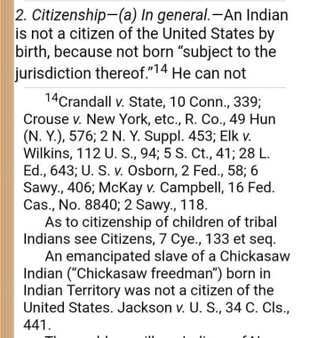 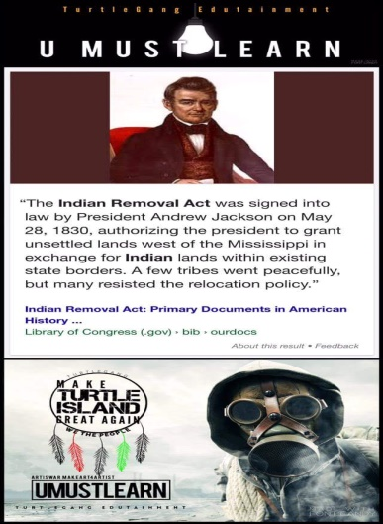 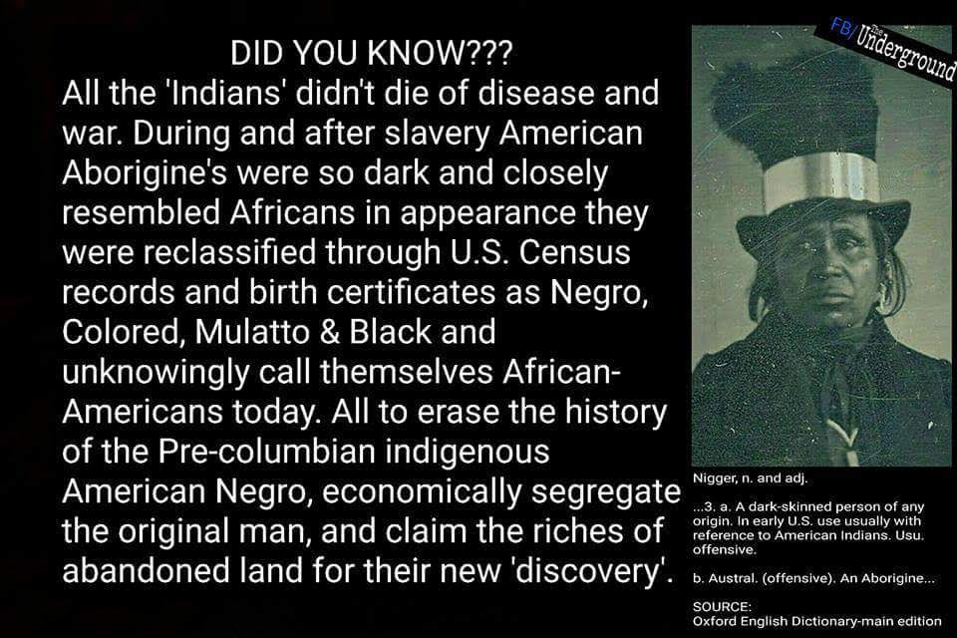

The “Old Settlers”, were given an Agent to protect them in their new home in Arkansas; Major William Lewis Lovely. The County was named for a year after the Agent Surname, “Lovely County Arkansas”.

The “United Band of Keetoowah that were taken to Arkansas made their way back to Georgia”, after being deceived. They called this era for our ancestors, “The Trail of Tears”!

The Cherokee Nations of Georgia became the “New Echota Nations”, under “Roger Lovely”. The initial home for the New Echota Nations were said to have been in “Fort Benning Georgia”, but later moved to “Edison Georgia”.

The United Band of Cherokee Keetoowah People efforts to maintain their cultural and spiritual practices reorganized and formed “The Nighthawk Keetoowah Tribe”. This group of “Old Settlers” maintained their cultural and spiritual practices at night; such as: Star gazing and

Listening to the heartbeat of mother’s nature.

This gathering of the Light- skinned and dark-skinned families was not permitted after 1890.

1836, several business men got together and decided to demand the United Band of Cherokee Keetoowah of Southwest Georgia to give their Agricultural and Timber Rich Land to the White Settlers for a mere $200,000; all the land in Georgetown, Georgia (Militia District 118), Cuthbert, Georgia (Militia District 718) and Lumpkin, Georgia.

1837, the Full blood Keetoowah women were married off to the highest bidder in Arkansas in 1837, under the Administration of “Roger Lovely and Susan Chadwick Proctor”, and brought back to Southwest, Georgia and Eastern Alabama, to begin the Patrilineage control over their Indigenous land.

1845, the Christian Missionaries began establishing their Churches, in order to “Civilized “the Indigenous owners of the land; and demanded that they cease observing their spiritual beliefs and practices “accept Jesus Christ as their savior”. The Cherokee Keetoowah of Georgia was put under the protection of “Bishop Henry McNeal Turner”, an Episcopal Ministers in 1890. Bishop Turner was the first Chaplin in the Military, and was the head of the Union Army. He, along with “Richard Allen and Absalom Jones, established the Churches for the Freedmen and the Baptist Churches were established for the Slaves.” **Written by Principal Chief, Betty Jones- Smith (Flying Mink) is the descendants of Roger Lovely, Susan Chadwick Proctors and Absalom Jones.**

The Great Seal of the Phoenix Cheasequah El Bey Tribe

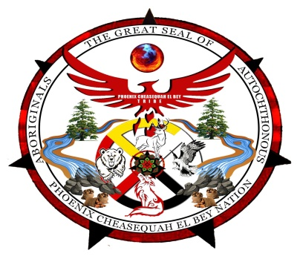

Our Great Seal has signs and symbols of Ancient Wisdom. Overall it gives a glimpse into our rich history, oral tradition and journey as a people.

The Symbols are:

The Phoenix (Cheasequah)

SUN

White Deer

Red tail Hawk

Red Wolf

Bear

Potatoes

Two Cedar Trees

Water (Swamp)

​PHOENIX (CHEASEQUAH) RED BIRD in Cherokee language: Phoenix Spirit Represents the Continuous Cycle of Life, Death, and Rebirth & Resurrection of Our People. Seat of Primal Life Force, the KA (Spirit) Kundalini Energy Rising within lives eternally. Element of Fire & more. Also Great name of our Chief Red Wolfs direct ancestry.

​SUN (Nvdoigaehi): As Children of the SUN we give thanks & reverence for the Sun & its Rays of Potent & Enriching Vitamin D gives us our Melanin Rich Glow, these same rays of energy give us successful, plentiful crops to feed our people. The Rise & Set of the Sun describes the various Cycles of Life. Element of Fire & more.

​WHITE DEER (Awinageehi): North

Deer Spirit represents the Heart of Great Spirit (Creator); White Deer appears to the Spiritual Seeker on the Sacred Path of Divine Purpose, Spiritually in tuned & aware to the voice of Great Spirit & more.

​REDTAIL HAWK (TAWODI): East

Hawk/Falcon Represents the Element of Air. Messenger of Great Spirit who brings "TRUTH “to its people. Deciphering Signs & Symbols, relaying important messages to our people. A Seer with Keen Vision. Guardianship; Guardian of the Divine Messages, wisdom, insight. Leadership, Creativity, Strength & more.

RED WOLF (WAYA): South the Red Wolf Spirit is the Great Teacher, the Warrior Spirit of Our People. In tuned with the Wolf Pack. Self-sufficient, Intuition, Insight, Loyalty, Leadership & more. The red wolf is only found in the South Eastern parts of America. (Chief Amir Bey’s Spirit Animal)

​BEAR (Alisoqualvdi): West the Bear Spirit is Introspection, Hibernation, Courage, Power, Diligence, gateway to other worlds, especially Dream world & more.

​WILD POTATOES (Nunaanisaqualu): We are Natural Born Blood Descendants of the Anigatogewi "White/Wild Potato Clan" Farmers that plant the eyes of potatoes in small mounds so they grow to feed our people. An Element of Earth, We are the Protectors of Grandmother Earth & more.

CEDAR (A-TS-NA-TLU-GV) TREE:

Cedar Tree Represents the "SPIRIT OF OUR ANCESTORS" POWERFUL PROTECTIVE SPIRITS.

An Element of Earth. 2 Cedar Trees represents BALANCE & more.

WATER (Ama): Water is Life, an Element that nourishes us, our Crops (Roots, Herbs, Plants, Vegetables) Animals etc. The Swaps were filled with water to aid the growth of our sacred wild potatoes & more.

We are not Native Americans by blood but by Definition. 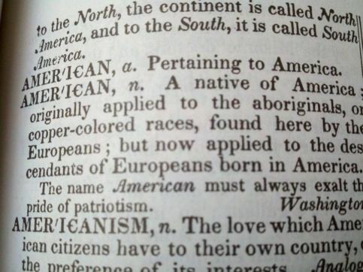

The word INDIAN was used to describe the Aboriginals of America or Turtle Island. INDIA was known as Hindustan or Deccan. “India” likens to INK it means, Black Pigment. Also The Spanish Meaning of Indios or Indigo the darkest shade, meaning Gods People.

See: Webster’s New World Dictionary (Third College Edition, 1988), p.686 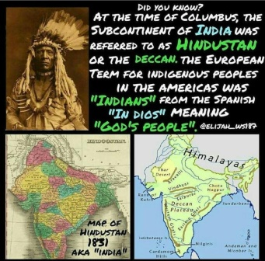

​We are known as the First Nations, the Aboriginal, Indigenous, and Autochounous of Turtle Island.

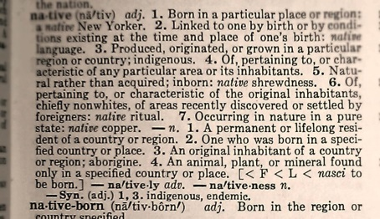 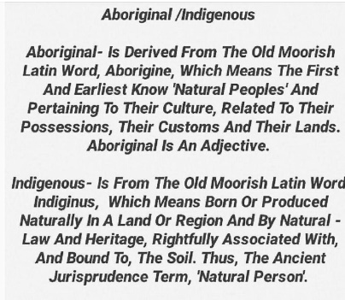 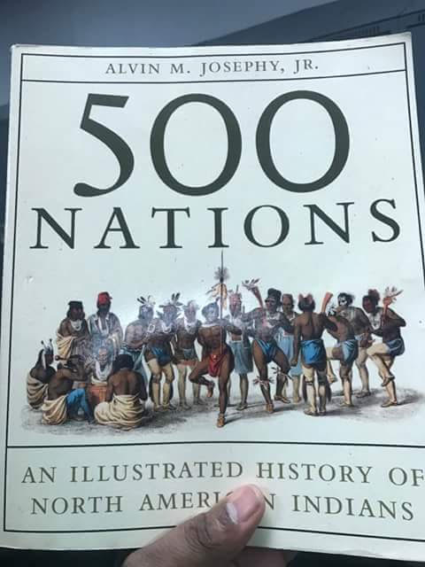

So we honor and thank Our Ancestors (Angus Phoenix Sr. and Julia Johnson Phoenix) for leaving us a blazing trail to follow. The Phoenix family, Clan, and Tribe will Rise from the ashes like the Mythology explains.

